15IT304J – WEB PROGRAMMING LAB

**SEMESTER - VI**

**Name : Register No. :**

**Class : III B.Tech. IT**

**2018 - 2019**



**FACULTY OF ENGINEERING AND TECHNOLOGY SRM INSTITUTE OF SCIENCE AND TECHNOLOGY**

**(Under Section 3 of UGC Act, 1956)**

S.R.M. NAGAR, KATTANKULATHUR – 603 203

KANCHEEPURAM DISTRICT

**SRM INSTITUTE OF SCIENCE AND ECHNOLOGY**

**(Under Section 3 of UGC Act, 1956) S.R.M. NAGAR, KATTANKULATHUR – 603 203**

**KANCHEEPURAM DISTRICT**

**BONAFIDE CERTIFICATE**

**Register No.:**

*Certified to be the bonafide record of work done by*

*of*

*B.Tech. Degree*

*course in the Practical in*

*SRM Institute of Science and Technology, Kattankulathur during the academic year __ .*

**Lab Incharge**

**Date: Head of the Department**

**Dr.G.Vadivu**

*Submitted for University Examination held on at SRM Institute of Science and Technology, Kattankulathur.*

**Date:**

**Internal Examiner I Internal Examiner II**

**INDEX**

|  |  |  |  |  |  |
| --- | --- | --- | --- | --- | --- |
| **Ex. No** | **Date** | **Name of the Experiment** | **Page**  **No.** | **Mark** | **Signature** |
| **0** |  | **Installation, Environment**  **Preliminaries** |  |  |  |
| **1** |  | **Creating web pages using HTML5 Semantic and Structural Elements** |  |  |  |
| **2** |  | **Design the web pages using Cascading**  **Style Sheet (CSS 3.0)** |  |  |  |
| **3** |  | **Design dynamic web pages with validation using JavaScript** |  |  |  |
| **4** |  | **i) Creating mysql database and tables in *phpmyadmin***  **ii) Database Connectivity using PHP** |  |  |  |
| **5** |  | **Creating web pages with menu and Navigation with client server interaction** |  |  |  |
| **6** |  | **Implementing business logic using PHP** |  |  |  |
| **7** |  | **Implementing session and cookies in the web pages using PHP** |  |  |  |
| **8** |  | **Simple applications using JSP and Servlets** |  |  |  |
| **9** |  | **Simple application for accessing the data using XML** |  |  |  |
| **10** |  | **Simple applications using AJAX** |  |  |  |
| **11** |  | **Application for web services** |  |  |  |

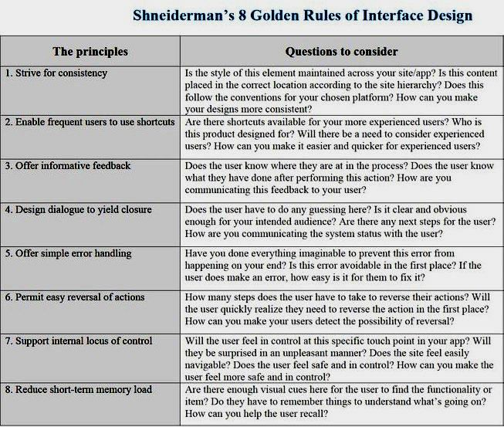

**SRM INSTITUTE OF SCIENCE AND ECHNOLOGY Department of Information Technology**

**Rubrics for Grading 15IT304J – Web Programming Laboratory**

|  |  |  |  |  |  |  |
| --- | --- | --- | --- | --- | --- | --- |
| **Experiment**  **Component** | **Max.**  **Marks** | **Grading Rubrics** | | | | |
| Layout Design | 2 | Layout and Design, focusing alignment of content and elements in web page (demonstrates good clarity in understanding the problem statement). To Maintain the Coding Standards Commenting, Naming conventions, Portability and Creativity in design is taken care off.  **[2 marks]** | | | Layout and Design are implemented, but lack of clarity in alignment of content to solve the given problem and lack of creativity in design (demonstrates less clarity in understanding the problem statement) and lack of coding standards. Correctness of layout design in web page is taken care off. **[1 mark]** | |
| Business Logic | 3 | Completeness of code, consistent in maintaining coding standards and best practices, usage of existing skills in new ways/learns new skills to solve the experimental  problem.  **[3 marks]** | Completeness of code, inconsistent in maintaining coding standards, lacks clarity in modularity, uses existing skills to solve the experimental problem.  **[2 marks]** | | | Completeness of code, inconsistent in maintaining coding standards, lacks clarity in modularity, uses existing skills to partially solve the experimental problem.  **[1 mark]** |
| Web Page  Deployment | 3 | Web page is free of errors and web page design is well formatted. Demonstrates Excellent problem solving and creativity skills.  **[3 marks]** | Web page is free of errors and web page design is not properly  formatted. Demonstrates a clear  understanding of the concepts relevant to the experiment.  **[2 marks]** | | | Web page contains few logical errors and web page design is not formatted.  Demonstrates partial understanding of the concepts relevant to the experiment.  **[1 mark]** |
| Web page Testing | 2 | Web page is tested using better design and creativity and works with logical requirement  **[2 marks]** | | Web page works only with logical requirement and lacks good design and creativity  **[1 mark]** | | |

General Instructions to Students:

This lab course is intended to provide a practical approach to understand the concepts behind the lab exercises. Hence the students are asked to follow the guidelines scrupulously.

* The Student should develop a web-site (using HTML, CSS and PHP) right from the starting of the first exercise to the 7th exercise while incrementally develop the exercises in the given order. (Refer Index for the order of exercises).
* The relevant source codes must be maintained safely for the submission at the end of the semester in a CD.
* The web-site should have at-least 10 dynamic web pages with first page being home page. The project should be created in such a way to demonstrate the description of the lab exercises.
* Write the project title and one page description in the space provided. And get the approval from the course handling faculty.
* Every student is expected to do individual project only. The title of the project should be unique and subjected to the approval of the course handling faculty.
* Complete every Lab experiment on the same day of the lab.
* The screen shots of the lab exercises and its relevant source codes are to be printed out and get attested by the course handling faculty. [Note: Maintain the copies in a stick file]

**Faculty In-charge**

Note: Write the project title and one page description. And get the approval from the course handling faculty.

**Faculty In-charge**

**Ex.No. 0. Understanding the functionality of web clients and web servers.**

**Server Side:** Install XAMPP software and Host a sample website (Use sample templates) in Apache Server

**Client Side:** Install Firebug plugins in Mozilla Firefox browser and explore the developer's options

Note: Install Aptana Studio, XAMPP and sublime text and explore its functionalities with simple programs.

**Ex.No.: 1 a) Create a login page for your project using HTML.**

**b) Create a user registration page of the project with all possible form elements.**

**Hint:**

* Create a banner for page header using any image editor (Photoshop, MS Paint, etc.)
* Create a footer content
* HTML tags: paragraph, h1 to h6, anchor, fonts, lists
* Form elements: input box, password, list box, check box, button, radio button, option button.
* HTML 5: audio, video tags
* Layouts using tables, div and span, HTML structural elements.

**Sample Page:**

**User Login Form :**

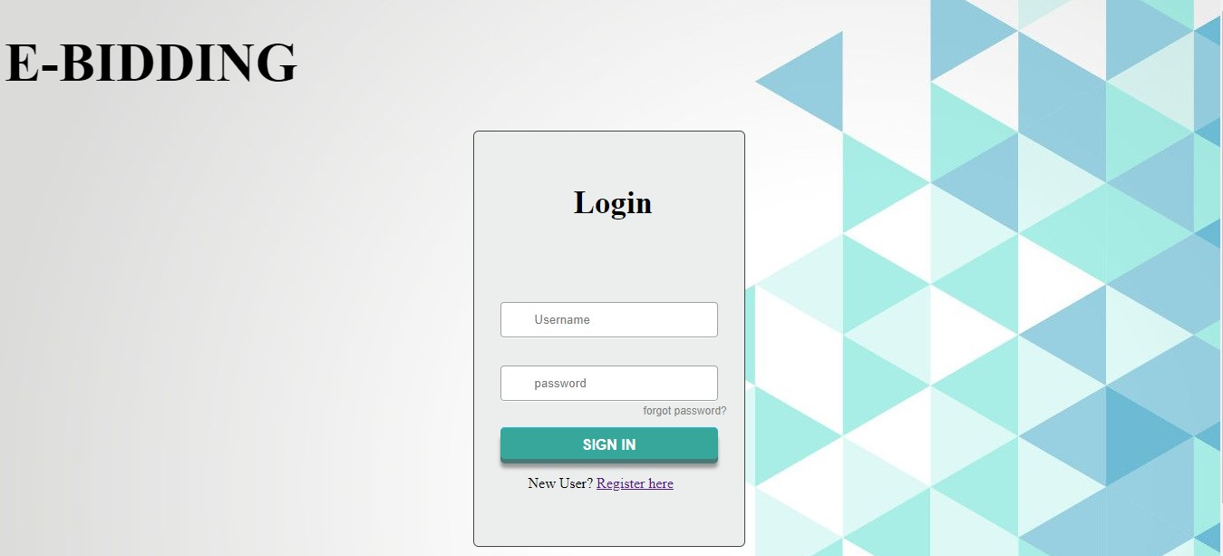

Login html:

<!DOCTYPE html>

<html>

<head>

<link rel="stylesheet" href="loginstyle.css">

<script>

function validateForm() {

var x = document.forms["myForm"]["uname"].value;

if (x == "") {

alert("Name must be filled out");

return false;

}

}

</script>

</head>

<style>

#name1{

font-size: 60px

}

</style>

<body style="background-image: url(web-designer-pune-background.jpg)">

<form name="myForm" onsubmit="return validateForm()" method="post">

<h1 id="name1" >E-BIDDING</h1>

<div class="login">

<h5 style="font-size: 35px; padding-left: 110px">Login</h5>

<input type="text" name="uname" placeholder="Username" id="username" >

<input type="password" placeholder="password" id="password">

<a href="#" class="forgot">forgot password?</a>

<input type="submit" value="Sign In"></br>

<p23 style="padding-bottom: 20px;padding-left: 60px"> New User? <a href="register.php">Register here</a> </p23>

</div>

<div class="shadow"></div>

</form>

</body>

</html>

**User Registration Form :**

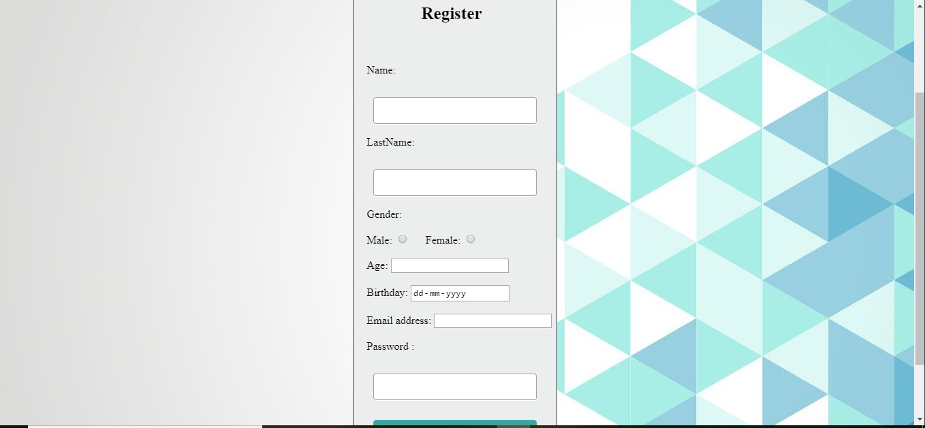

Register html:

<!DOCTYPE html>

<html>

<head>

<link rel="stylesheet" href="registerstyle.css">

<script>

function validateForm() {

var x = document.forms["myForm"]["uname"].value;

if (x == "") {

alert("Entries must be filled out");

return false;

}

}

</script>

</head>

<style>

#name1{

font-size: 60px

}

</style>

<body style="background-image: url(web-designer-pune-background.jpg)">

<form name="myForm" onsubmit="return validateForm()" method="post">

<h1 id="name1" >E-BIDDING</h1>

<div class="login">

<h5 style="font-size: 25px; padding-left: 100px">Register</h5></br>

<label style="padding-left: 20px">Name:<input type="text" name="fname"></label></br></br>

<label style="padding-left: 20px">LastName:<input type="text" name="lname"></label></br></br>

<label style="padding-left: 20px">Gender:</label></br></br>

<label style="padding-left: 20px">Male:</label>

<input type="Radio" name="maleorfemale value=">

<label style="padding-left: 20px">Female:</label>

<input type="Radio" name="maleorfemale value="> </br> </br>

<label style="padding-left: 20px">Age:</label>

<input type="number"> </br></br>

<label style="padding-left: 20px">Birthday:</label>

<input type="date" name="bday"> </br> </br>

<p5 style="padding-left: 20px">Email address:</p5>

<input type="email" name="uname" Email address=""></br></br>

<p6 style="padding-left: 20px" >Password :</p6>

<input type="password"></br>

<input type="Submit" value="Submit" > </br> </br>

<p23 style="padding-bottom: 20px"> Already a member? <a href="login.php">click to login </a> </p23>

</div>

<div class="shadow"></div>

</form>

</body>

</html>

**Ex.No.: 2 a) Format the login page using CSS 3.0**

**b) Format the user registration page using CSS 3.0**

**Hint:**

* Styling
  + Font
  + Color
  + Background
* Alignment
  + Box model
* Positioning
  + Static
  + Relative
  + Absolute
  + Fixed
  + Float

**Update the *UserLogin.html* file, created in Lab 1**



**Login css:**

**html { height: 100% }**

**::-moz-selection { background: #fe57a1; color: #fff; text-shadow: none; }**

**::selection { background: #fe57a1; color: #fff; text-shadow: none; }**

**body { background-image: radial-gradient( cover, rgba(92,100,111,1) 0%,rgba(31,35,40,1) 100%), url('http://i.minus.com/io97fW9I0NqJq.png') }**

**.login {**

**background: #eceeee;**

**border: 1px solid #42464b;**

**border-radius: 6px;**

**height: 457px;**

**margin: 20px auto 0;**

**width: 298px;**

**}**

**.login h1 {**

**background-image: linear-gradient(top, #f1f3f3, #d4dae0);**

**border-bottom: 1px solid #a6abaf;**

**border-radius: 6px 6px 0 0;**

**box-sizing: border-box;**

**color: #727678;**

**display: block;**

**height: 43px;**

**font: 600 14px/1 'Open Sans', sans-serif;**

**padding-top: 14px;**

**margin: 0;**

**text-align: center;**

**text-shadow: 0 -1px 0 rgba(0,0,0,0.2), 0 1px 0 #fff;**

**}**

**input[type="password"], input[type="text"] {**

**background: url('http://i.minus.com/ibhqW9Buanohx2.png') center left no-repeat, linear-gradient(top, #d6d7d7, #dee0e0);**

**border: 1px solid #a1a3a3;**

**border-radius: 4px;**

**box-shadow: 0 1px #fff;**

**box-sizing: border-box;**

**color: #696969;**

**height: 39px;**

**margin: 31px 0 0 29px;**

**padding-left: 37px;**

**transition: box-shadow 0.3s;**

**width: 240px;**

**}**

**input[type="password"]:focus, input[type="text"]:focus {**

**box-shadow: 0 0 4px 1px rgba(55, 166, 155, 0.3);**

**outline: 0;**

**}**

**.show-password {**

**display: block;**

**height: 16px;**

**margin: 26px 0 0 28px;**

**width: 87px;**

**}**

**input[type="checkbox"] {**

**cursor: pointer;**

**height: 16px;**

**opacity: 0;**

**position: relative;**

**width: 64px;**

**}**

**input[type="checkbox"]:checked {**

**left: 29px;**

**width: 58px;**

**}**

**.toggle {**

**background: url(http://i.minus.com/ibitS19pe8PVX6.png) no-repeat;**

**display: block;**

**height: 16px;**

**margin-top: -20px;**

**width: 87px;**

**z-index: -1;**

**}**

**input[type="checkbox"]:checked + .toggle { background-position: 0 -16px }**

**.forgot {**

**color: #7f7f7f;**

**display: inline-block;**

**float: right;**

**font: 12px/1 sans-serif;**

**left: -19px;**

**position: relative;**

**text-decoration: none;**

**top: 5px;**

**transition: color .4s;**

**}**

**.forgot:hover { color: #3b3b3b }**

**input[type="submit"] {**

**width:240px;**

**height:35px;**

**display:block;**

**font-family:Arial, "Helvetica", sans-serif;**

**font-size:16px;**

**font-weight:bold;**

**color:#fff;**

**text-decoration:none;**

**text-transform:uppercase;**

**text-align:center;**

**text-shadow:1px 1px 0px #37a69b;**

**padding-top:6px;**

**margin: 29px 0 0 29px;**

**position:relative;**

**cursor:pointer;**

**border: none;**

**background-color: #37a69b;**

**background-image: linear-gradient(top,#3db0a6,#3111);**

**border-top-left-radius: 5px;**

**border-top-right-radius: 5px;**

**border-bottom-right-radius: 5px;**

**border-bottom-left-radius:5px;**

**box-shadow: inset 0px 1px 0px #2ab7ec, 0px 5px 0px 0px #497a78, 0px 10px 5px #999;**

**}**

**.shadow {**

**background: #000;**

**border-radius: 12px 12px 4px 4px;**

**box-shadow: 0 0 20px 10px #000;**

**height: 12px;**

**margin: 30px auto;**

**opacity: 0.2;**

**width: 270px;**

**}**

**input[type="submit"]:active {**

**top:3px;**

**box-shadow: inset 0px 1px 0px #2ab7ec, 0px 2px 0px 0px #31524d, 0px 5px 3px #999;**

**}**

**Update the *Registration.html* file, created in Lab 1**



**Register css:**

**html { height: 100% }**

**::-moz-selection { background: #fe57a1; color: #fff; text-shadow: none; }**

**::selection { background: #fe57a1; color: #fff; text-shadow: none; }**

**body { background-image: radial-gradient( cover, rgba(92,100,111,1) 0%,rgba(31,35,40,1) 100%), url('http://i.minus.com/io97fW9I0NqJq.png') }**

**.login {**

**background: #eceeee;**

**border: 1px solid #42464b;**

**border-radius: 10px;**

**height: 700px;**

**margin: 40px auto 0;**

**width: 298px;**

**}**

**.login h1 {**

**background-image: linear-gradient(top, #f1f3f3, #d4dae0);**

**border-bottom: 1px solid #a6abaf;**

**border-radius: 6px 6px 0 0;**

**box-sizing: border-box;**

**color: #727678;**

**display: block;**

**height: 43px;**

**font: 600 14px/1 'Open Sans', sans-serif;**

**padding-top: 14px;**

**margin: 0;**

**text-align: center;**

**text-shadow: 0 -1px 0 rgba(0,0,0,0.2), 0 1px 0 #fff;**

**}**

**input[type="password"], input[type="text"] {**

**background: url('http://i.minus.com/ibhqW9Buanohx2.png') center left no-repeat, linear-gradient(top, #d6d7d7, #dee0e0);**

**border: 1px solid #a1a3a3;**

**border-radius: 4px;**

**box-shadow: 0 1px #fff;**

**box-sizing: border-box;**

**color: #696969;**

**height: 39px;**

**margin: 31px 0 0 29px;**

**padding-left: 37px;**

**transition: box-shadow 0.3s;**

**width: 240px;**

**}**

**input[type="password"]:focus, input[type="text"]:focus {**

**box-shadow: 0 0 4px 1px rgba(55, 166, 155, 0.3);**

**outline: 0;**

**}**

**.show-password {**

**display: block;**

**height: 16px;**

**margin: 26px 0 0 28px;**

**width: 87px;**

**}**

**input[type="checkbox"] {**

**cursor: pointer;**

**height: 16px;**

**opacity: 0;**

**position: relative;**

**width: 64px;**

**}**

**input[type="checkbox"]:checked {**

**left: 29px;**

**width: 58px;**

**}**

**.toggle {**

**background: url(http://i.minus.com/ibitS19pe8PVX6.png) no-repeat;**

**display: block;**

**height: 16px;**

**margin-top: -20px;**

**width: 87px;**

**z-index: -1;**

**}**

**input[type="checkbox"]:checked + .toggle { background-position: 0 -16px }**

**.forgot {**

**color: #7f7f7f;**

**display: inline-block;**

**float: right;**

**font: 12px/1 sans-serif;**

**left: -19px;**

**position: relative;**

**text-decoration: none;**

**top: 5px;**

**transition: color .4s;**

**}**

**.forgot:hover { color: #3b3b3b }**

**input[type="submit"] {**

**width:240px;**

**height:35px;**

**display:block;**

**font-family:Arial, "Helvetica", sans-serif;**

**font-size:16px;**

**font-weight:bold;**

**color:#fff;**

**text-decoration:none;**

**text-transform:uppercase;**

**text-align:center;**

**text-shadow:1px 1px 0px #37a69b;**

**padding-top:6px;**

**margin: 29px 0 0 29px;**

**position:relative;**

**cursor:pointer;**

**border: none;**

**background-color: #37a69b;**

**background-image: linear-gradient(top,#3db0a6,#3111);**

**border-top-left-radius: 5px;**

**border-top-right-radius: 5px;**

**border-bottom-right-radius: 5px;**

**border-bottom-left-radius:5px;**

**box-shadow: inset 0px 1px 0px #2ab7ec, 0px 5px 0px 0px #497a78, 0px 10px 5px #999;**

**}**

**.shadow {**

**background: #000;**

**border-radius: 12px 12px 4px 4px;**

**box-shadow: 0 0 20px 10px #000;**

**height: 12px;**

**margin: 30px auto;**

**opacity: 0.2;**

**width: 270px;**

**}**

**input[type="submit"]:active {**

**top:3px;**

**box-shadow: inset 0px 1px 0px #2ab7ec, 0px 2px 0px 0px #31524d, 0px 5px 3px #999;**

**}**

**Ex. No.: 3 Validating user inputs of the web pages using Java Script**

**Instruction:**

**i)Validate the login form using Java script**

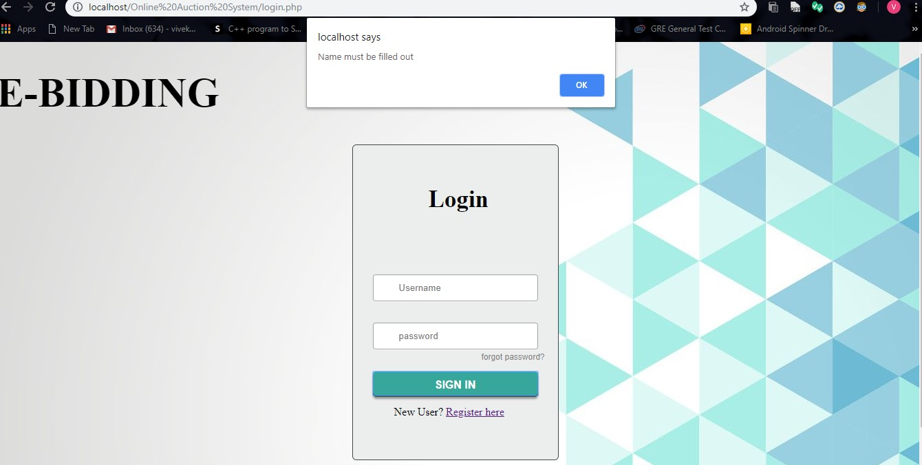

**Javascript login:**

**<script>**

**function validateForm() {**

**var x = document.forms["myForm"]["uname"].value;**

**if (x == "") {**

**alert("Name must be filled out");**

**return false;**

**}**

**}**

**</script>**

**ii) Validate the registration form using Java script**

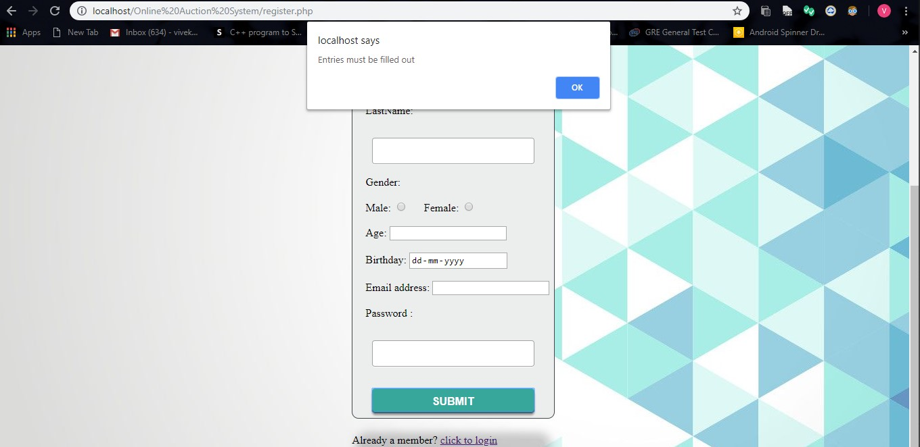

**Javascript Register:**

**<link rel="stylesheet" href="registerstyle.css">**

**<script>**

**function validateForm() {**

**var x = document.forms["myForm"]["uname"].value;**

**if (x == "") {**

**alert("Entries must be filled out");**

**return false;**

**}**

**}**

**</script>**

**Ex. No.: 4 a) Create a *mysql* database and all the tables of the project in *phpmyadmin*.**

**b) Write a PHP code to store user registration information in the database.**

**c) Write a PHP code for user login page.**

**Instruction:**

**Create table for the registration form in Mysql and store the details using PHP**

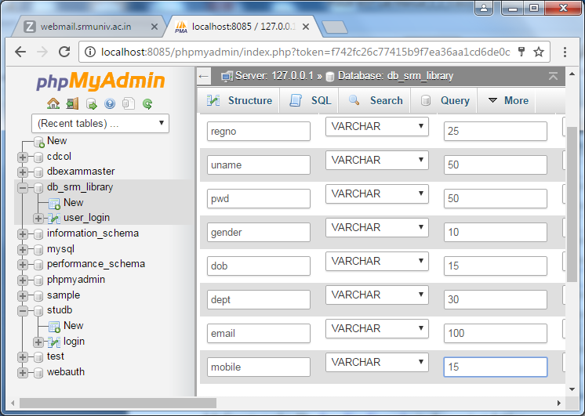

**Display confirmation for Successful registration**

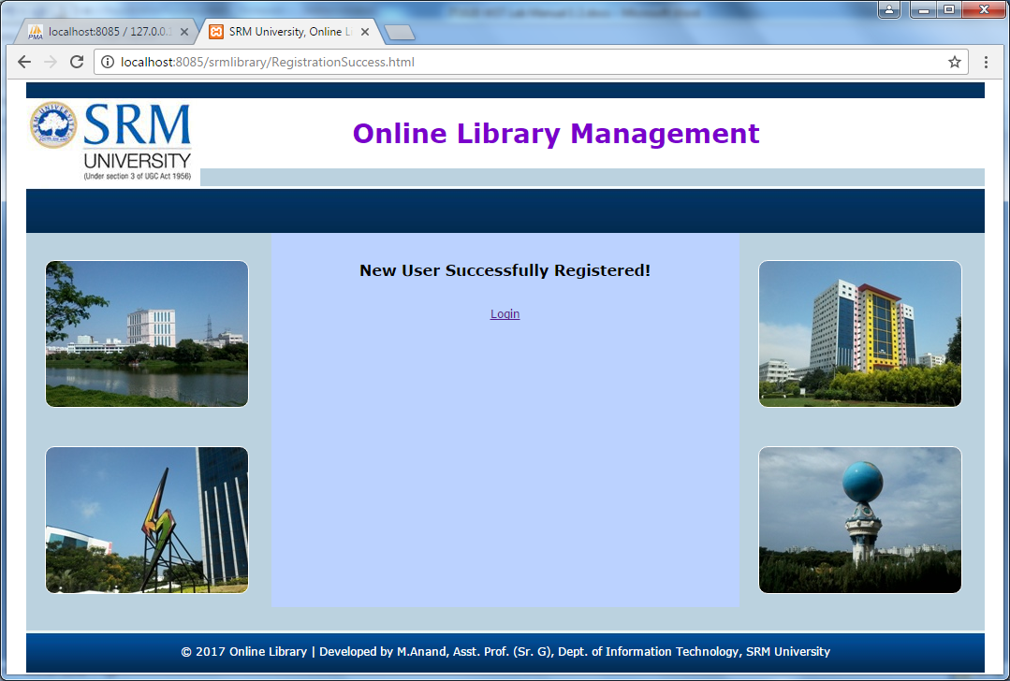

**Ex. No.: 5 Design menus and navigation of the project.**

**Sample Page :**

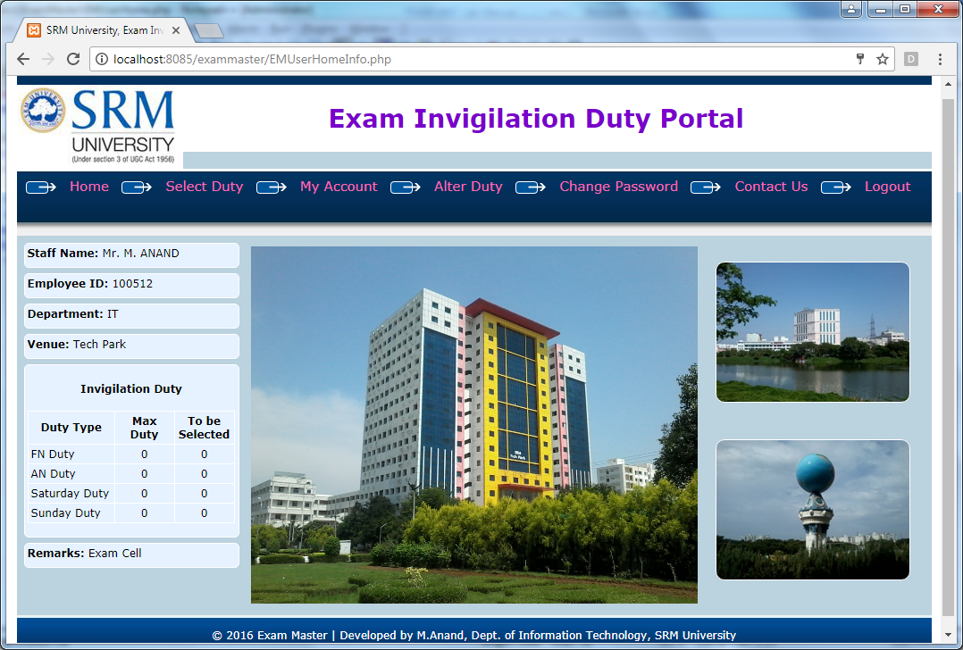

**Ex. No.: 6 Implement business logic of the project.**

**Instruction:**

**According to the students project appropriate business logic can be implemented with the required database insertion and retrieval operations**

**Ex. No.:7 Create a cookie to save the username and password and display it in the respective field when the user returns to the webpage**

**Instruction:**

**Create cookie using PHP to save username and password and display it in the respective field when the user returns to the webpage**

**Ex. No.: 8 Creating user login and registration pages using Servlet and JSP**

**Instruction:**

**Create login page and registration page using i) Servlet and ii) JSP**

**Login page**

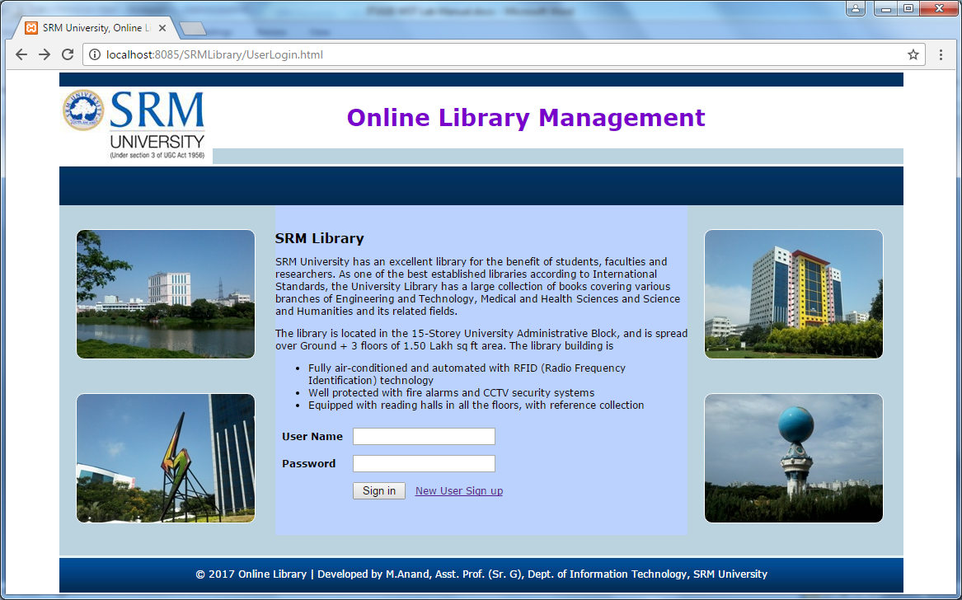

**Registration Page:**

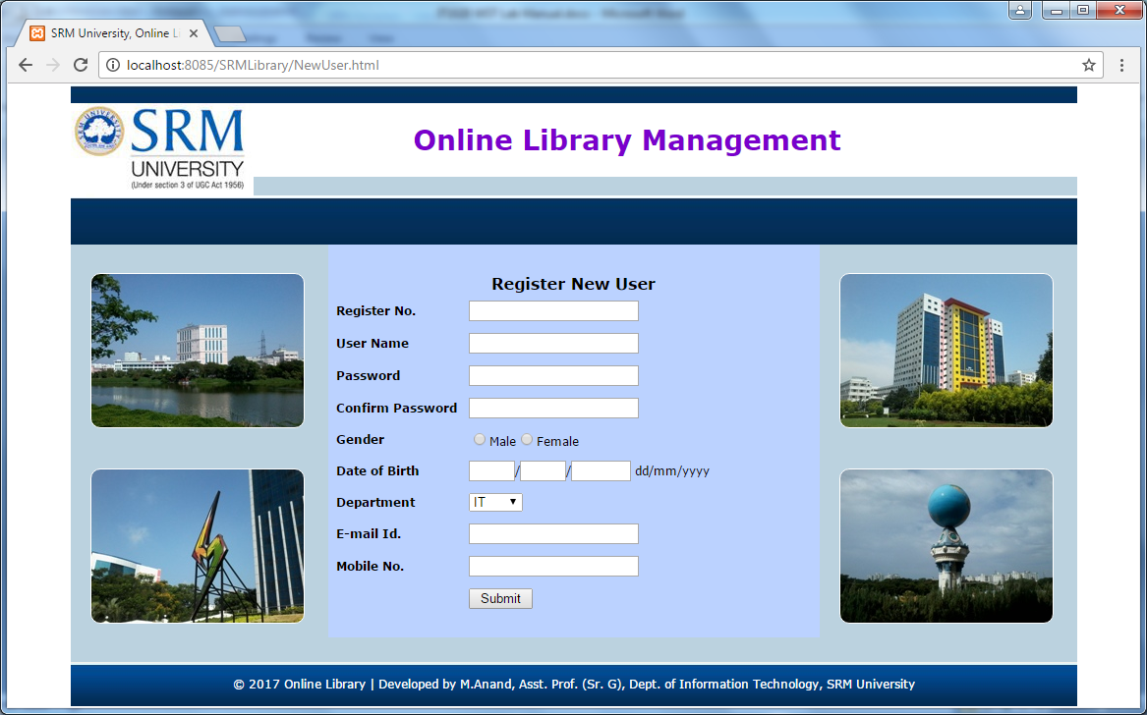

**Ex. No.: 9 Design simple application for accessing the data using XML**

**Instruction:**

* Students should learn the features of xml syntax, DTD, Schema.
* Students should learn XSLT and CSS for document markup presentation.
* Students should learn DOM and SAX parsers for understanding data exchange through java program.

a) Make a XML which contains data of a product catalog for computer device specification.

Apply CSS and XSL to enable proper presentation in the browser.

b) Create a java program for given XML and DTD to check whether the given XML is well

formed and valid.

c) Use DOM parser to fetch the XML content and display in the console through java

program.

d) Use SAX parser to fetch the XML content and display in the console through java

program.

**Ex. No.: 10 Simple applications using AJAX**

**Instruction:**

Make a registration form with username, email, password, phone number and submit it to the database.(include client side and server side validation). Use AJAX to check for username availability in database while user is tying in input field and immediately update the status of user name availability in nearby span field. You can either use PHP or JSP for server side coding

|  |  |  |  |
| --- | --- | --- | --- |
| **Sl No:** | **Assessment Process Description** | | **Mark(s)** |
| 1 | Documentation/Procedure(2) | |  |
| 2 | Program(3) | |  |
| 3 | Program Execution(3) | |  |
| 4 | Program Testing(2) | |  |
|  | Total(10) | |  |
| Remarks |  | | |
| Date of Completion: | | Signature | |

**Result:**

**Ex. No.: 11 Application for Web Services**

**Instruction:**

Consume a Web service from following Web service providers. The service provider provides Temperature Unit conversion from one unit to other. Develop a client side java program to include the webservice component in its application. The value to be converted is taken from user and call for webservice should be done and result should be displayed back in the application.

**ConvertTemp** - A free Web service that converts temperature values in Celsius, Fahrenheit, Rankine, Reaumur, and Kelvin.

Technical information on the Web service:

* Service Operation Name: ConvertTemp
* Service Provider: WebserviceX.NET
* Service URL: <http://www.webservicex.net/ConvertTemperature.asmx>
* WSDL Document: http://www.webservicex.net/ConvertTemperature.asmx?WSDL
* WSDL version: WSDL 1.1
* SOAP version: SOAP 1.1 and SOAP 1.2
* SOAP message style: Document

Create a SoapUI project called "ConvertTemperature" with WSDL at "http://www.webservicex.net/ConvertTemperature.asmx?WSDL". You will see "ConvertTemp" displayed in the list of operations.

|  |  |  |  |
| --- | --- | --- | --- |
| **Sl No:** | **Assessment Process Description** | | **Mark(s)** |
| 1 | Documentation/Procedure(2) | |  |
| 2 | Program(3) | |  |
| 3 | Program Execution(3) | |  |
| 4 | Program Testing(2) | |  |
|  | Total(10) | |  |
| Remarks |  | | |
| Date of Completion: | | Signature | |

**Result:**